When participant eligibility is confirmed by both the Research Assistant and Study Pharmacist, you will receive an email notification with instructions on how to access the QI eligibility form on REDCap Academic.

If you did not receive the email notification, To access the form, log in to REDCap™ and complete the 2 Factor authentication process. Navigate to the 'My Projects' tab and select the 'CanTreatCOVID' project.



In the Data Collection panel on the left-hand side of the screen, click on 'Add/Edit Records' and select the subject ID from the dropdown menu. This will bring you to all forms for that particular subject.



1. Pharmacy Form - Complete by Pharmacist
   1. To be completed by the Pharmacist. The Research Assistant/ Coordinator will get in contact with your site Pharmacist to let them know that they have screened a new patient in, hence they require the Pharmacist to complete the Pharmacy Form.
   2. The Pharmacy Form will have a complete list of the medications the patient is currently taking, obtained from the patient’s usual pharmacy. If the Pharmacist finds that the participant is eligible for the study after reviewing the patient’s medications, the Pharmacist will inform the Qualified Investigator (You) of the province to approve the participant for the study.

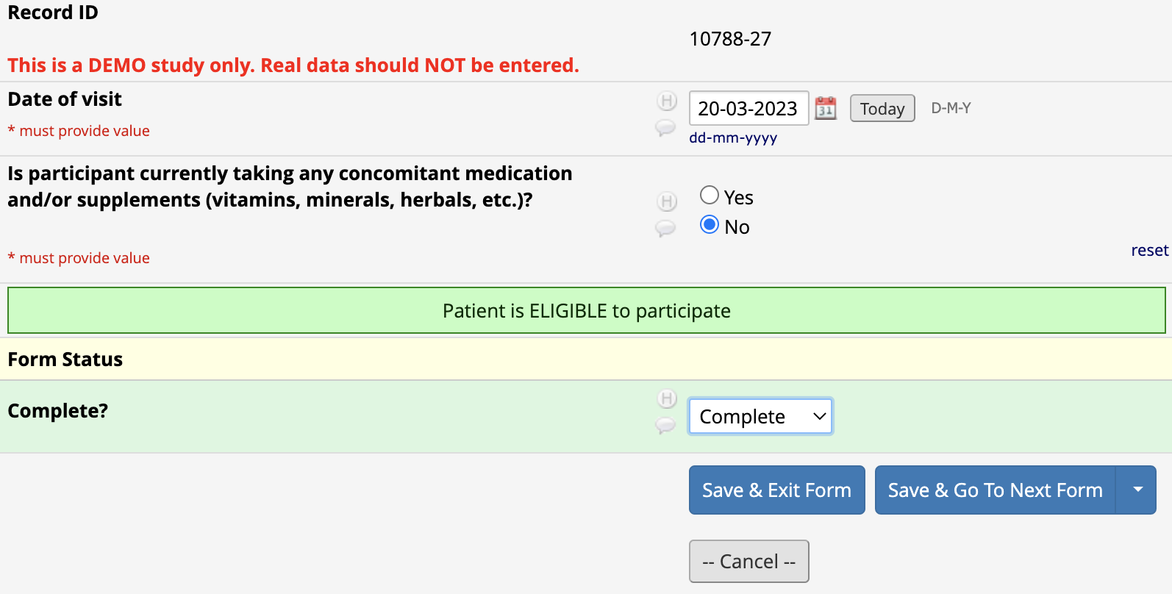

1. QI Eligibility Form
   1. You (Qualified Investigator) will review the Pharmacy Form, in which the medications and related health conditions are stated and then will approve or not approve the participant for the study.
      1. You will need to Agree (Yes) or Disagree (No) on the eligibility of the participant on the form
      2. You will need to Date, Sign and mark the Status as Complete prior to exiting the form by clicking Save and Exit Form.

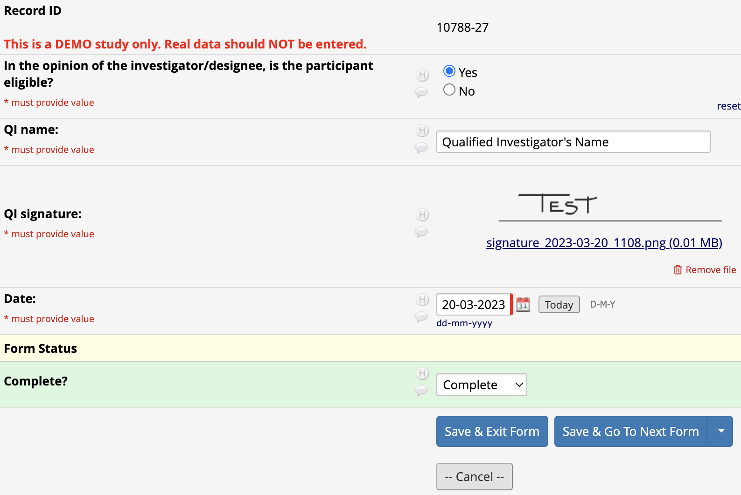

If you agree that the participant is eligible for the study, the participant will then be randomized to a study diary, will be randomized to a study arm, and the study medication will be shipped if applicable.